**SOLUTIONS SCREENSHOT**

1. S3 Bucket Created From Terraform

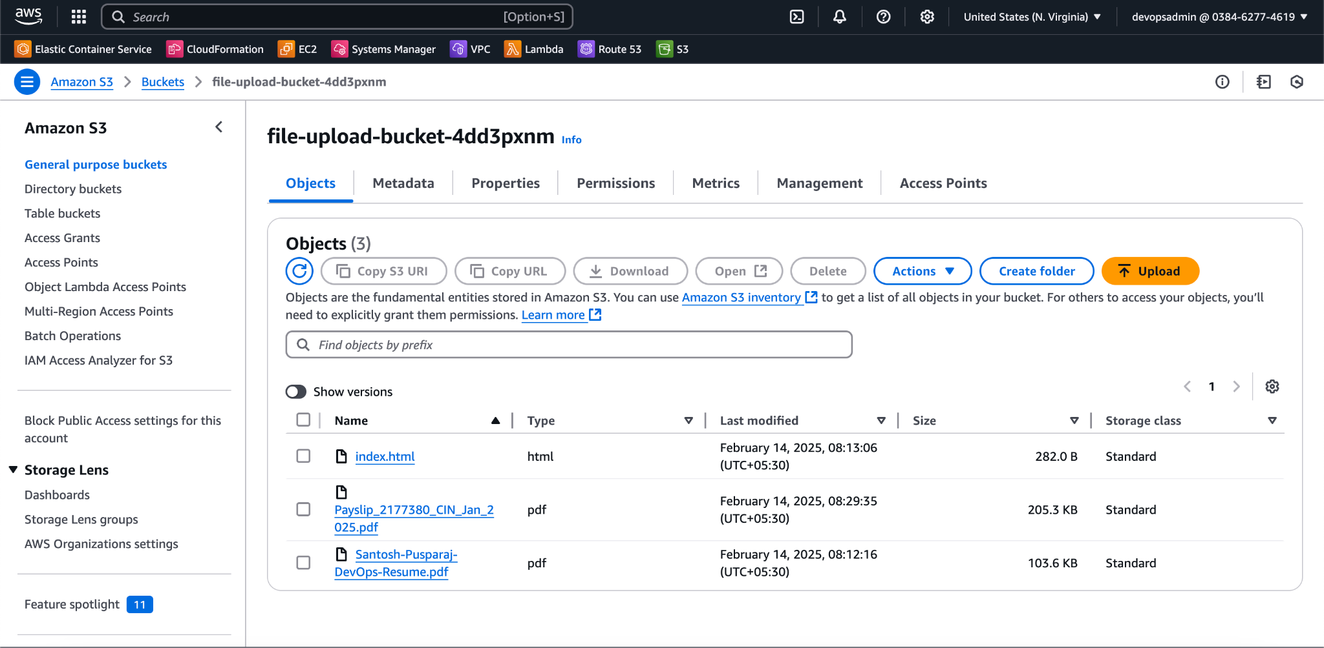

1. Once the s3 bucket is created, uploaded sample file named “Payslip_2177380_CIN_Jan_2025.pdf”
2. SNS Created using terraform will send out an email regarding the file upload.

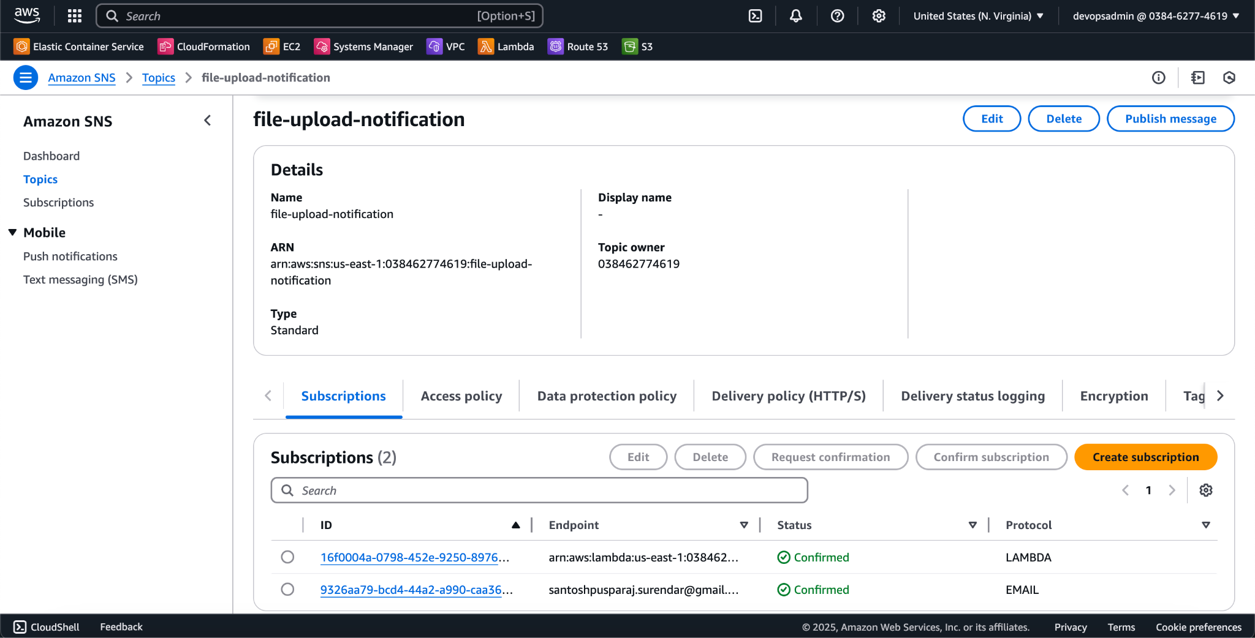

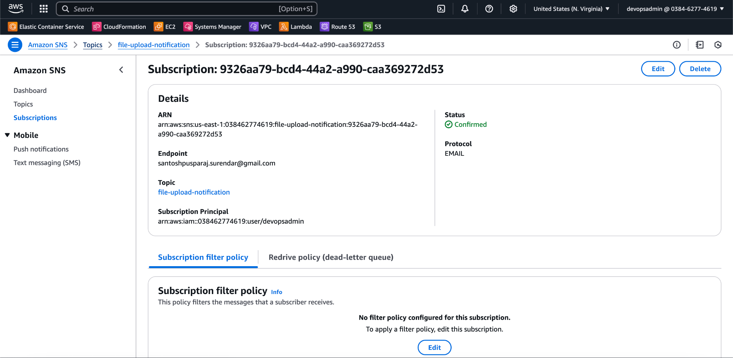

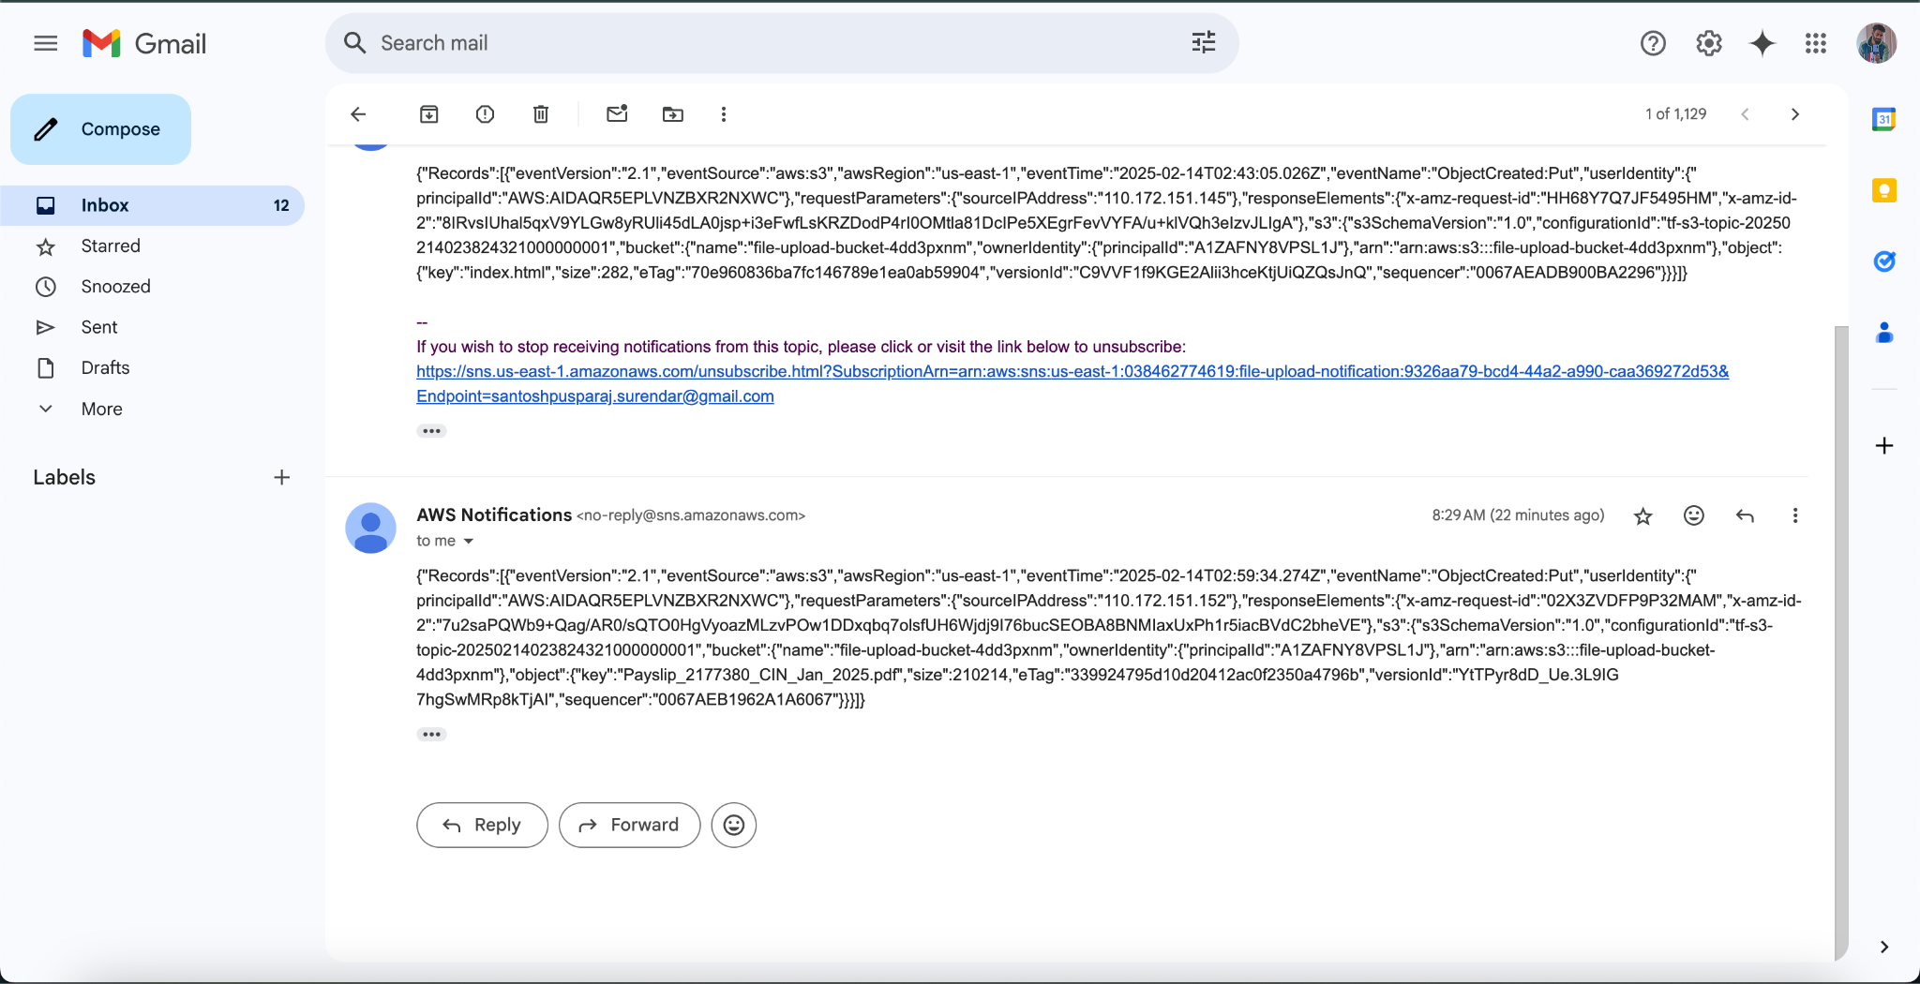

1. lambda function named “file_processor” created using terraform. (Python function attached as zip file in the terraform folder”.

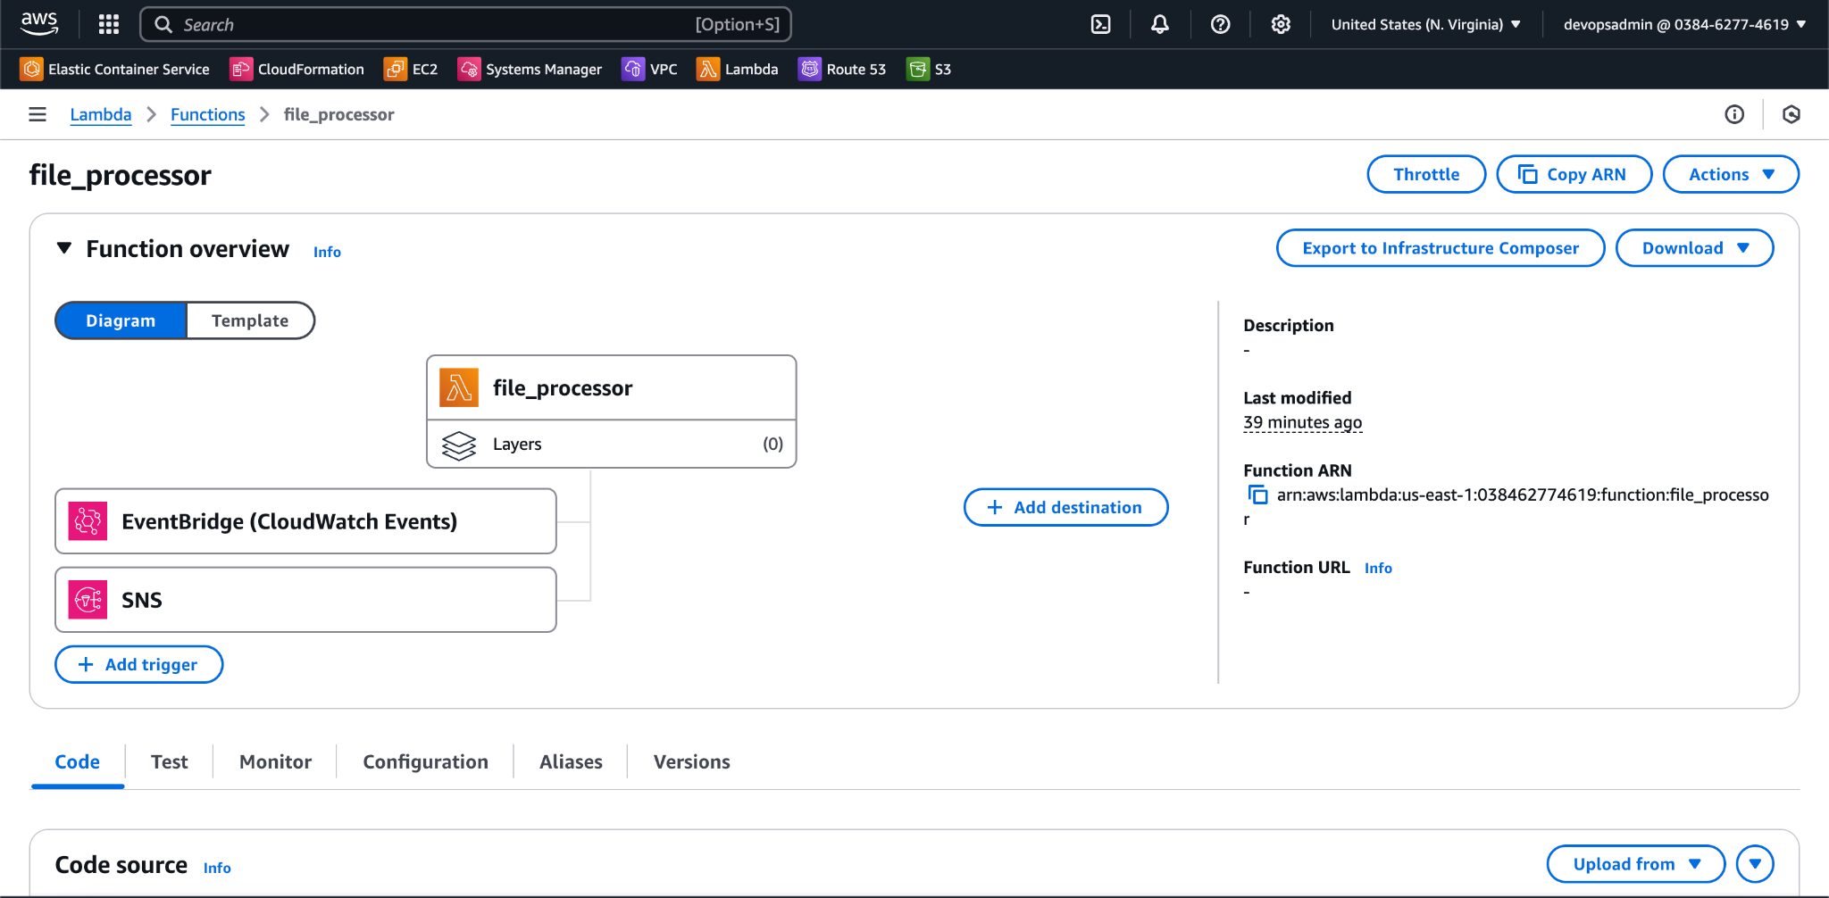

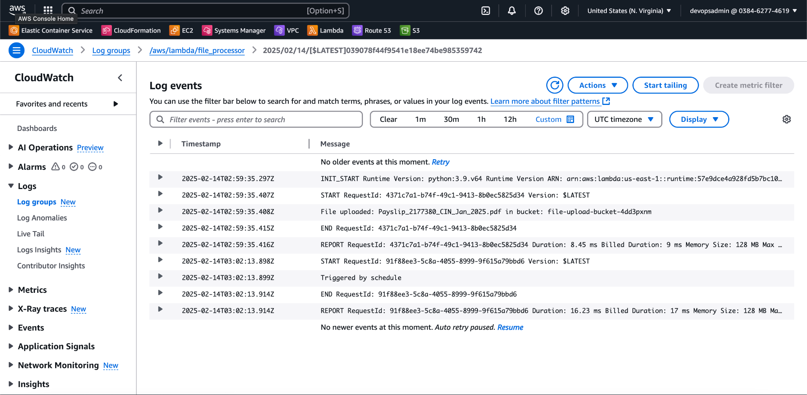

It will send out the logs to Cloudwatch logs and there displayed the filename.

1. Trigger_lambda.py is the python function which uses boto3 to trigger the lambda function from local.

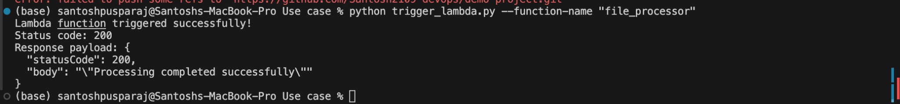

1. S3 Bucket is used as backend to store the terraform.statefiles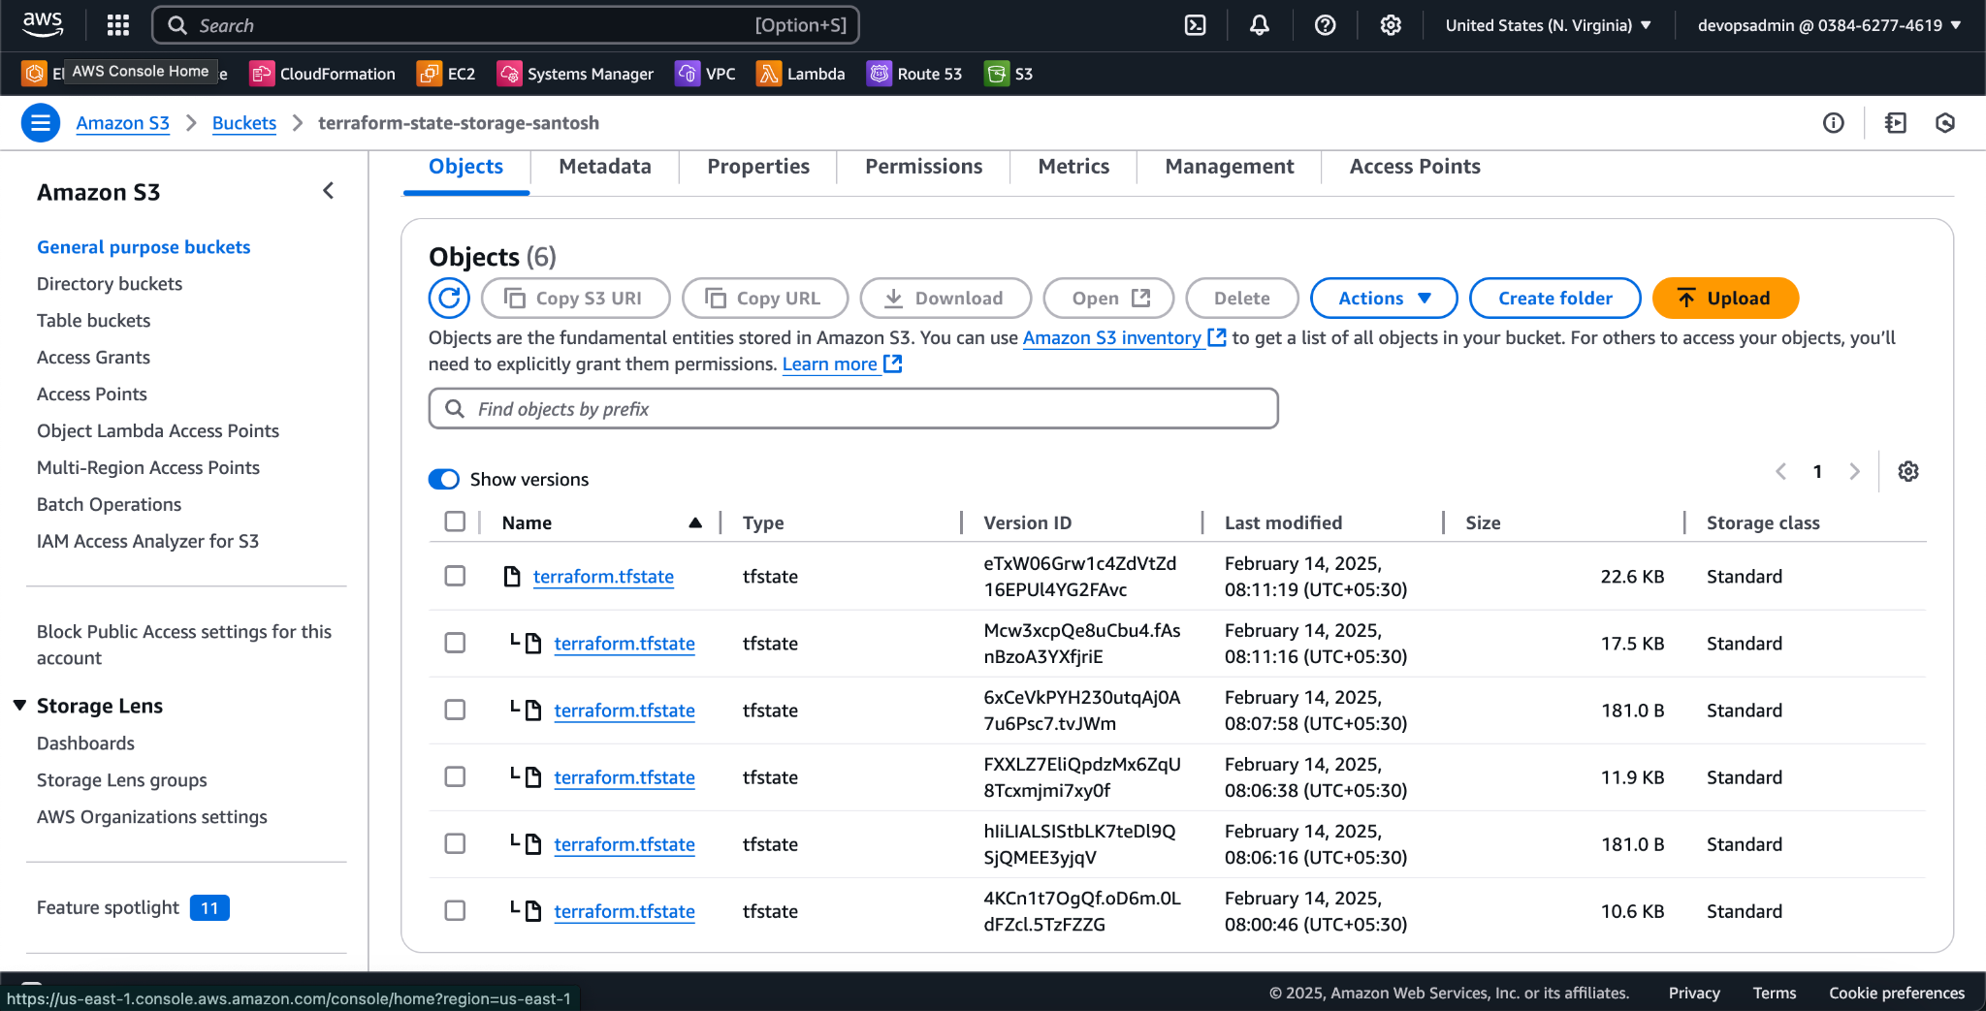
2. Dynamodb to acquire the state lock

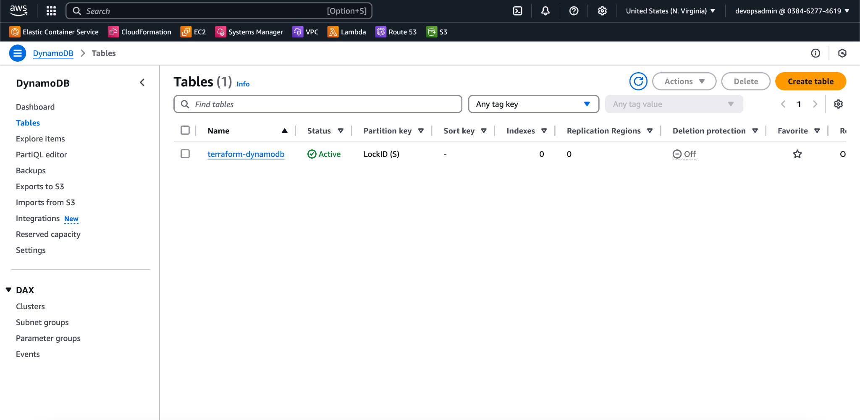



1. Terrform Configuration Screenshot

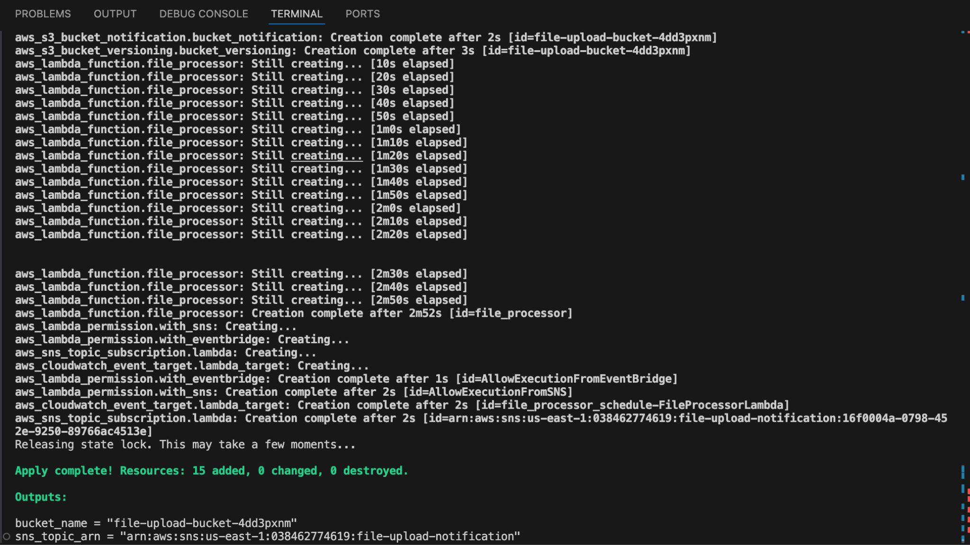

**Github Repo URL** : https://github.com/Santosh2109-devops/demo-project